A Neuromorphic Compute Node Architecture for Reproducible Hyper-Real-Time Simulations of Spiking Neural Networks

Guido Trensch^{1,3}, Abigail Morrison^{1,2,3}
¹ Simulation and Data Laboratory Neuroscience, Jülich Supercomputing Centre, Institute for Advanced Simulation, Jülich Research Centre, Jülich, Germany
² Institute of Neuroscience and Medicine (INM-6), Institute for Advanced Simulation (IAS-6), JARA-Institute Brain Structure-Function Relationship (JBI-1 / INM-10), Research Centre Jülich, Jülich, Germany
³ Department of Computer Science 3 - Software Engineering, RWTH Aachen University, Aachen, Germany

Email: g.trensch@fz-juelich.de
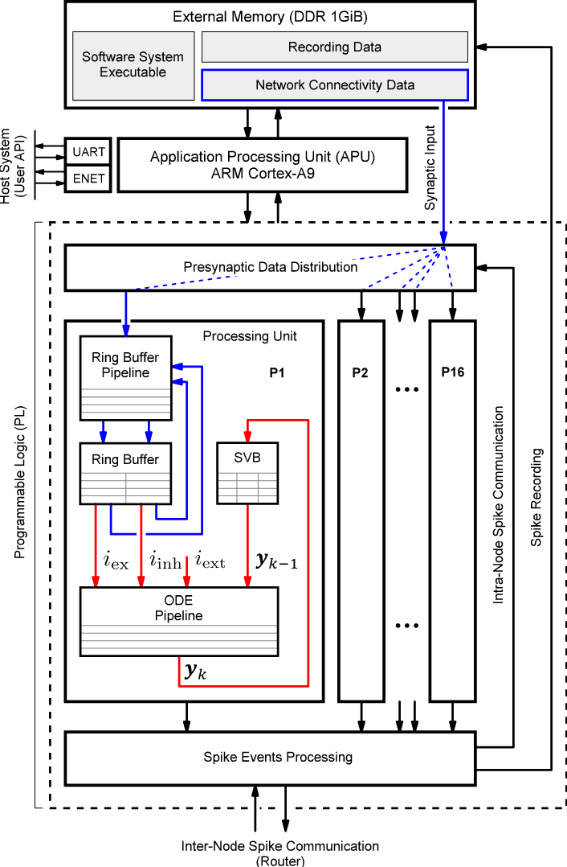 | 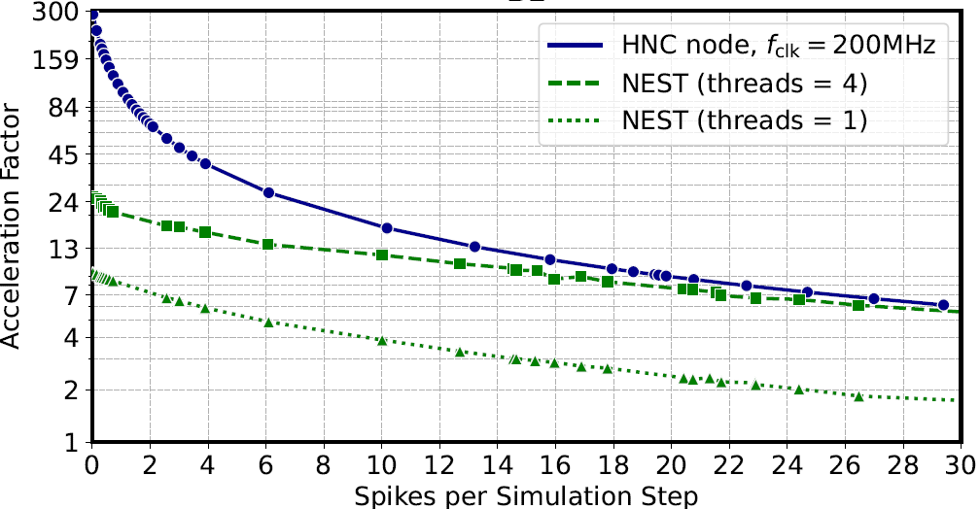  Neuromorphic compute node high-level architecture and its performance characteristics in comparison with NEST.
Despite the great strides neuroscience has made in recent decades, the underlying principles
of brain function remain largely unknown. Advancing the field strongly depends on the ability to
study large-scale neural networks and perform complex simulations. In this context, simulations
in hyper-real-time are of high interest, but even the fastest supercomputer available today is not able to meet the challenge of accurate and reproducible simulation with hyper-real acceleration. The development of novel neuromorphic computer architectures holds out promise. Advances in System-on-Chip (SoC) device technology and tools are now providing interesting new design possibilities for application-specific implementations. We propose a novel hybrid software-hardware architecture approach for a neuromorphic compute node intended to work in a multi-node cluster configuration [1]. The node design builds on the Xilinx Zynq-7000 SoC device architecture that combines a powerful programmable logic gate array (FPGA) and a dual-core ARM Cortex-A9 processor extension on a single chip [2]. Although high acceleration can be achieved at low workloads, the development also reveals current technological limitations that also apply to CPU implementations of neural network simulation tools.

Acknowledgements

The project has received funding from the Helmholtz Association’s Initiative and Networking Fund under project number SO-092 (Advanced Computing Architectures, ACA).

References
- Trensch, G., and Morrison, A. (2022). A System-on-Cip Based Hybrid Neuromorphic Compute Node Architecture for Reproducible Hyper-Real-Time Simulations of Spiking Neural Networks. [manuscript submitted to Frontiers in Neuroinformatics for publication]
- Zynq-7000 SoC Technical Reference Manual (UG585). Available online at: www.xilinx.com.

