**Physics-informed deep learning for multimodal image denoising**

Yogita Yogita1,2, Elena Corbetta1,2, Thomas Bocklitz1,2

*1. Institute of Physical Chemistry (IPC) and Abbe Center of Photonics (ACP), Friedrich Schiller University Jena, Member of the Leibniz Centre for Photonics in Infection Research (LPI), Helmholtzweg 4, 07743 Jena, Germany*

*2. Leibniz Institute of Photonic Technology, Member of Leibniz Health Technologies, Member of the Leibniz Centre for Photonics in Infection Research (LPI), Albert Einstein Strasse 9, 07745 Jena, Germany.*

**Keywords**: Image reconstruction, Physics-informed learning, Self-supervised learning, Robustness

Optical aberrations and diffraction effects play a major role in degrading the quality of images acquired by optical microscopes. Classical image-restoration techniques such as median filtering and the Gerchberg-Saxton algorithm have addressed these imperfections. While these methods enhance image quality, they can also introduce undesirable artefacts [1]. Recently, deep learning (DL) models have gained more attention in this area. However, training a deep neural network often requires a substantial amount of data, and the performance degrades significantly if training data is limited, which forms a major obstacle in critical areas such as medical diagnostics.

Physics-informed deep learning (PIDL) has significantly advanced various application domains, including medical imaging, fluid mechanics, material science, and many more [2]. However, the integration of domain-specific knowledge into DL remains a challenge. This study investigates the development and implementation of PIDL for denoising multimodal (MM) images. Each channel of MM images comprises three distinct modalities: Coherent Anti-Stokes Raman Scattering (CARS), Second Harmonic Generation (SHG), and Two-Photon Excited Fluorescence (TPEF). These modalities offer valuable insights for studying biological samples. CARS measurements specifically explore the molecular distribution of lipids, SHG measurements provide insight into structural proteins like collagen within tissues, and TPEF measurements identify specific molecules such as keratin and NADP(H).

We propose a Physics-Informed Inception-based Super-Resolution Convolutional Neural Network (PI-incSRCNN) that incorporates the underlying physical principles of noise generation into the loss function. This integration enhances both the interpretability of the model and its ability to accurately recover clean images from noisy observations under data-scarce conditions. Our findings demonstrate that integrating physical laws with incSRCNN architectures yields data-efficient, interpretable, and robust image restoration for multimodal biomedical microscopy.

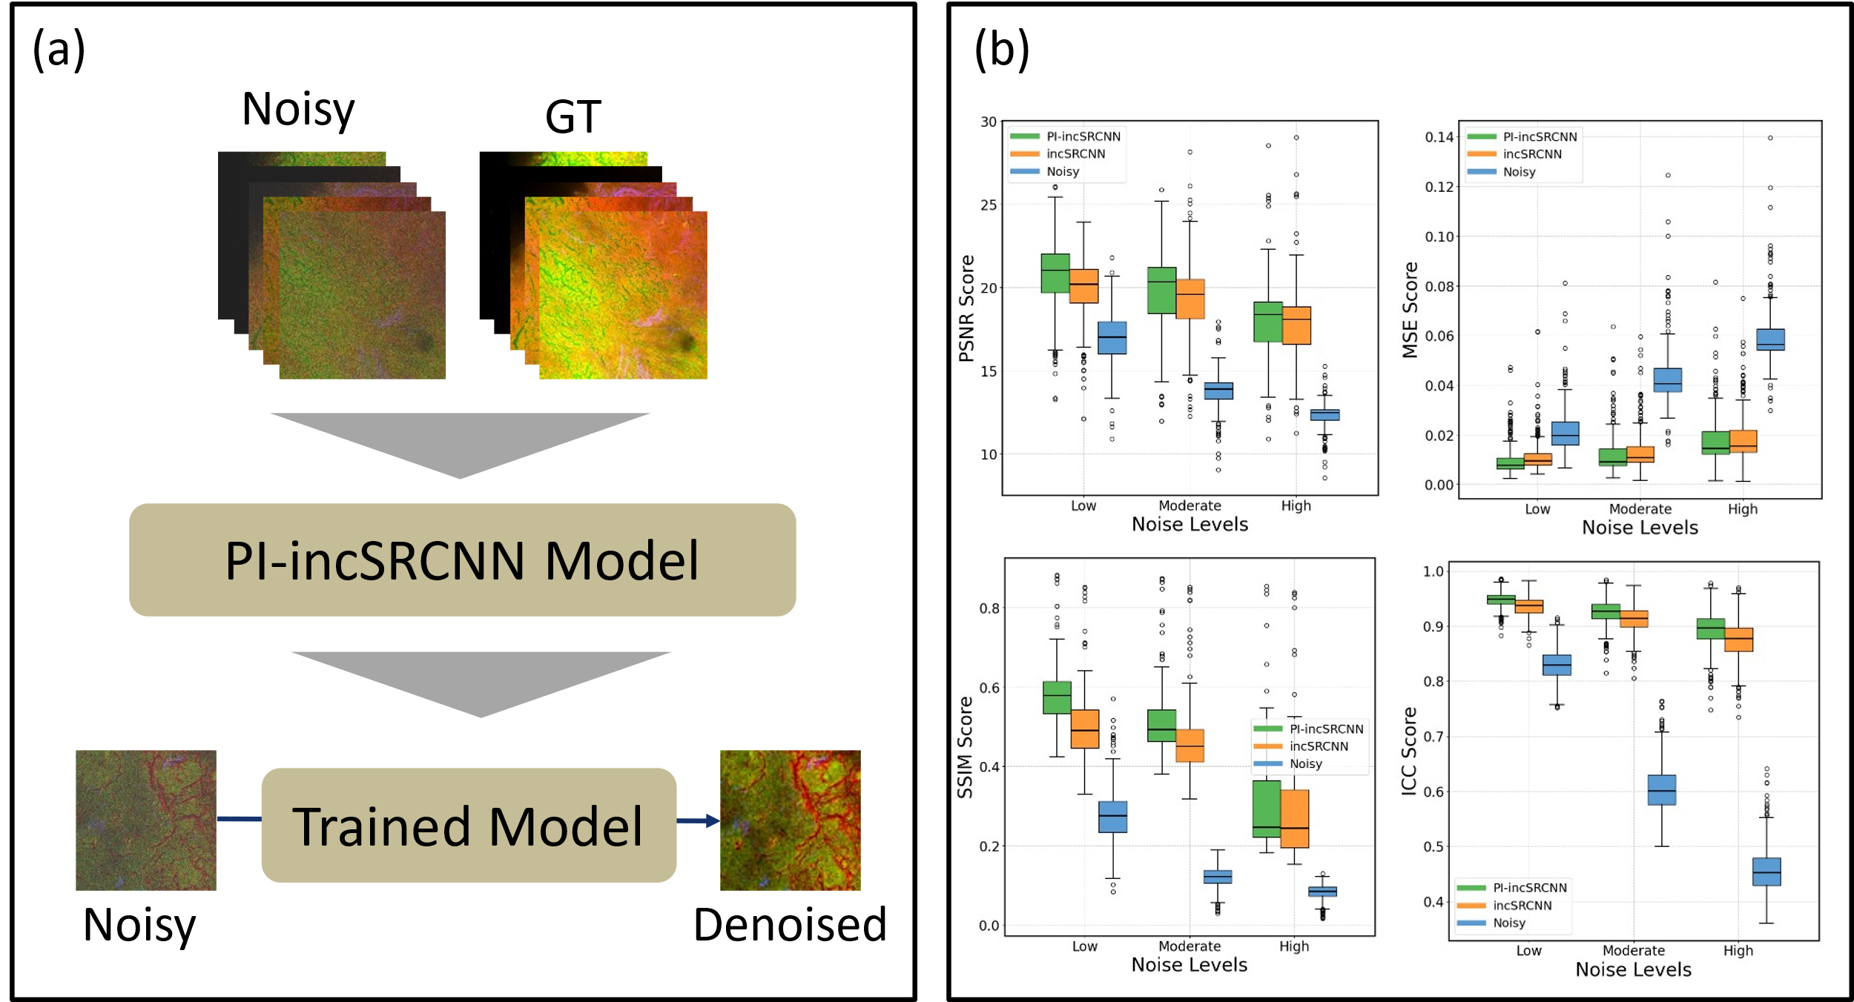

Figure 1. PI-incSRCNN for image denoising. (a) Workflow of PI-incSRCNN. The model is trained using paired Poisson-corrupted noisy and ground truth (GT) images. The loss function incorporates a physics-based term that models the Poisson noise generation process. MM images represent CARS, TPEF, and SHG modalities as the red, green, and blue channels, respectively. (b) Quantitative assessment was performed on denoised images from the standard incSRCNN, the proposed PI-incSRCNN, and the original noisy images with respect to the GT, using standard image quality metrics.

**References**

1. Houhou, Rola, et al. "Comparison of denoising tools for the reconstruction of nonlinear multimodal images." *Biomedical Optics Express* 14.7 (2023): 3259-3278.
2. Karniadakis, G. E., et al. "Physics-informed machine learning: Nature Reviews Physics." (2021): 422-440.
3. Yogita, Yogita, et al. "Physics-informed deep learning for multimodal image denoising." (*under review*)