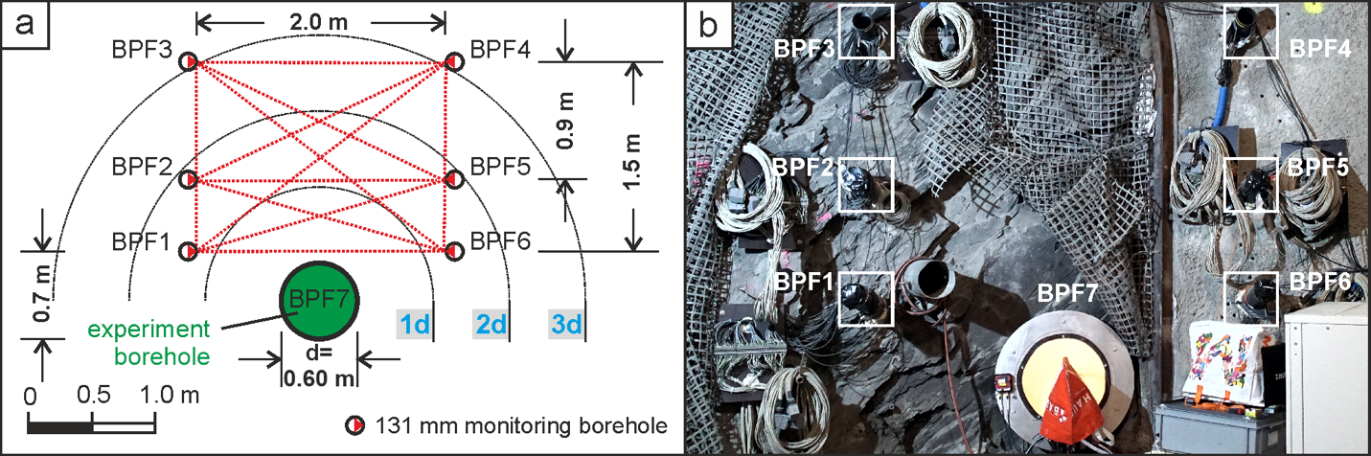
Figure 1: (a) Layout in plane view of the PF project’s borehole array. Six monitoring boreholes (BPF1–6) locate above a central, large, and unsupported experiment borehole (BPF7). (b) Overview photograph of the installed experiment location at the MI niche of the Mont Terri URL. Modified after M. Ziegler, Swiss Federal Office of Topography (swisstopo).

