**EWPAA 2024, September 17th - 19th, Helmholtz-Zentrum Dresden-Rossendorf e.V., Dresden**   
**Title of Your Oral Contribution, First Letter Capitalised**

**Presenting Author Name**a,1**, [Optional] Contributing Author One**b,2

*Presenting Author Affiliation*

a

*[Optional] Contributing Author One Affiliation*

b

*[Optional] Contributing Author Two Affiliation*

c

**1. Abstract**

Place your abstract here. Use this to convey the most crucial points of your presentation, but please keep in mind that each contribution in this summary will be limited to a single page in 2-column 9-point font (including figures and tables), so be brief.

**2. Typical Section**

You may use the \section command to add structure to your contri- bution. This will also appear in the Table of Contents at the front of

**and [Optional] Contributing Author Two**b,c,3

Figures should not be more than 90% of the column width, but making them narrower can be a good way to reduce the page length if you are struggling to comply!

**4.2. Tables**   
Table 1 shows an example table. The \tabletext{} is used to add notes to tables easily.

**Table 1.** Small example table.

the final proceedings document.

You can also use the \subsection command to add further struc- ture to your contribution.

**Column 1**

Data 1 Data 3

**Column 2**

Data 2 Data 4

**2.1. Units**   
Please remember to use a \, small space to separate quantities and measurements from their units, and please try to use SI units.

**3. References**

You may use references if you wish, though we suggest that you limit

Note: I’m a table text for additional information.

**5. Equations**

You can include equations which require the LATEX *amssymb* package. Equation 1 shows the Schrödinger equation as an example of this with a reference number which can be used in your text if desired.

this to a maximum of 5 references. Your references will appear as footnotes on this page using the \footnote command to make them easy for a reader to see and to ‘compartmentalise’ your contribution.

ℏ2

2𝑚∇

2Ψ + 𝑉(𝐫)Ψ = −𝑖ℏ𝜕Ψ

𝜕𝑡

(1)

Ideally you should include the DOI as a hyperlink in the reference, as this example shows 1. We will not insist on a particular format for

your references, but recommend that you adopt the standard IPAC JACoW format.

**4. Figures and Tables**

**4.1. Figures**   
Fig. 1 shows an example figure. The inclusion of a figure is very nice to break-up what would otherwise be a dull page for the reader, and so we encourage you to include at least one figure. You might even use two or even three, but remember that you must limit your total contribution to a single page.

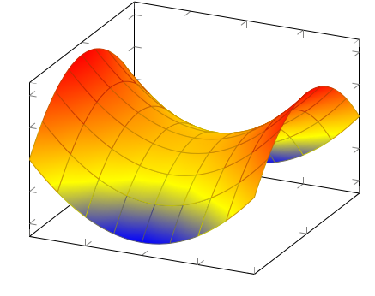

4

2

0

*−*2

**6. File Naming Convention**

To aid us in the compilation of the final workshop summary doc- ument, please use the following convention to name your source files:

• Source – ‘*EWPAA_Contribution_Surname,FirstName*’

• Figure – ‘*EWPAA_Contribution_Surname,FirstName_Figure*’

substituting ‘*Surname*’ and ‘*FirstName*’ appropriately. If you include more than one Figure in your contribution, then append numbers 1,2 etc. to the Figure filenames. Please send all files to the workshop organisers for compilation of the proceedings document.

**7. Outlook and Future Work**

Tell us about what you plan to do next, and where you hope the work shared in your contribution will lead.

*−*4

*−*2

*−*1

0

1

2

0

2 *−*2

**Figure 1.** Example figure with a caption.

1M.A. Schwartz; J Cell Sci 1 June 2008; **121** (11): 1771

**Page 1of 1**