Real-time Imaging Pipelines for Tomography

Computed Tomography (CT) is a powerful technique for 3D imaging of the interior of a wide range of objects, with applications in medicine, industry, and science. As a mixed experimental-computational method, it can be combined with various imaging modalities including X-ray imaging, optical imaging, and electron microscopy. In this lecture I will discuss the various challenges involved in speeding up the tomography pipeline towards the point where the object can be analyzed in full 3D during the scan. Real-time 3D imaging leads to the opportunity of adjusting the scanning process in real-time, which in turn paves the way for developing “intelligent” CT-systems that can interact with the operator to achieve more informative data acquisition.

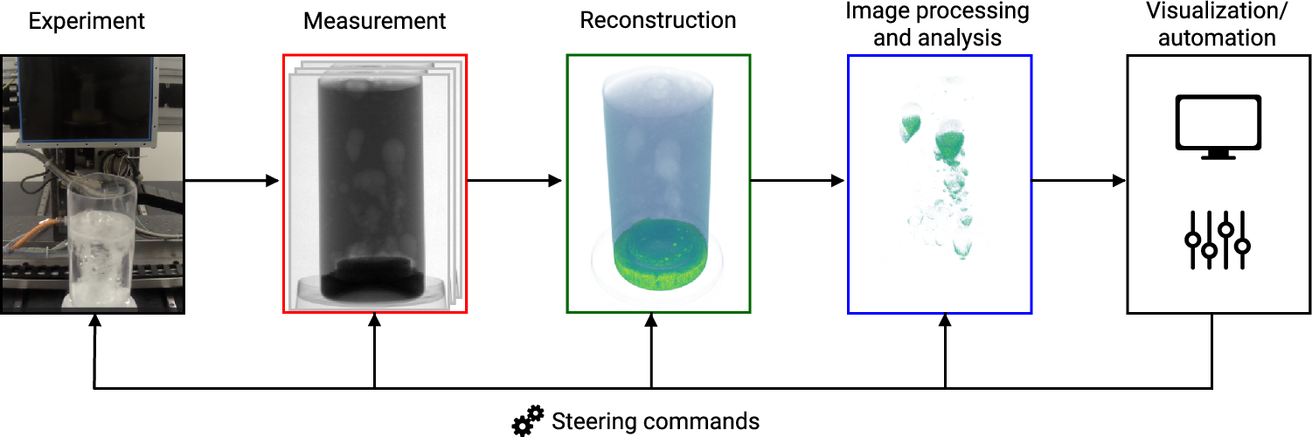

From: A. Graas et al., “Just-in-time deep learning for real-time X-ray computed tomography”,Scientific Reports, 13, 20070, 2023, <https://doi.org/10.1038/s41598-023-46028-9>